Athletic Registration

User Guide for Parents

November 2020

Table of Contents

Athletic Registration 1

Accessing the Student Athletic Registration 1

Completing the Athletic Registration 4

Registration Tab 6

Saving a Registration before Completion 7

Consent Tab 8

Insurance Tab 10

Medical Tab 11

Documents Tab 13

Final Tab 15

After Application is Submitted 16

# Athletic Registration

Use the Athletic Registration to submit the required consent, insurance, and medical information for your student’s athletic registration. Students must be in grades eight through twelve to register for athletics.

## Accessing the Student Athletic Registration

To access the Athletic Registration Application, log into your ParentVUE account. Two links to the ParentVUE login are available from the on the Cobb County School District’s home page **(**[**www.cobbk12.org**](http://www.cobbk12.org)**).** Mouse over “LOGIN” and click ParentVUE Login or from the “MENU” tab on the far left of the home page select “Parents & Students” followed by “Sign In” and lastly ParentVUE.

**Or  
**

Then select “I am a parent” on the following screen:

If you do not have a ParentVUE account or are unable to access your account after attempting to use the *Forgot Password* link, please contact the ParentVUE coordinator at your local school.

A list of ParentVUE coordinators can be found on the ParentVUE login screen.

After logging into ParentVUE, select the student who needs a registration. Then, click the Athletic Registration link in the Navigation menu.

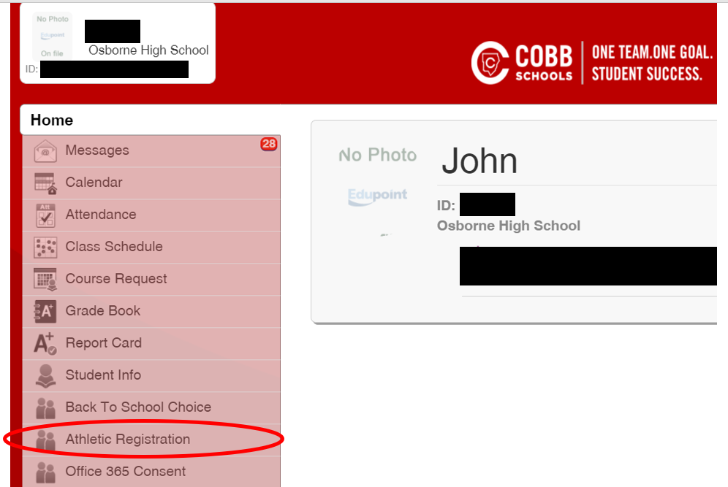

# Completing the Athletic Registration

Click the link, Athletic Registration that will display in the main window of ParentVUE.



The CCSD Athletic Registration Application will open. Click the Student Registration link located in the upper right corner of the screen.

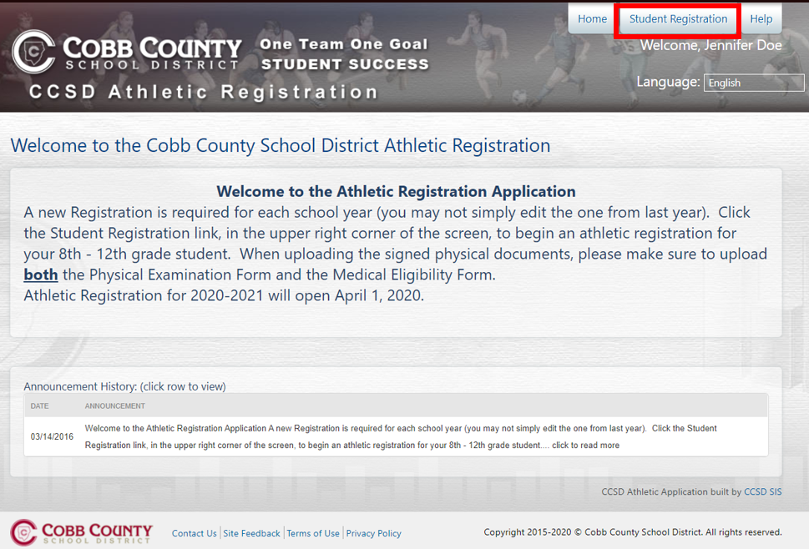

To begin the registration process, click the button **+ Start New Registration**.

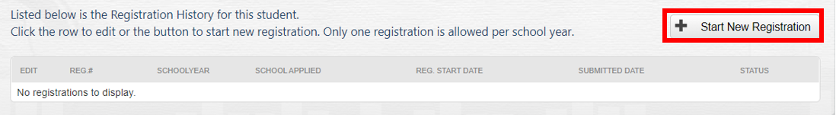

## 

## Registration Tab

Select the desired school year, for the registration, by clicking the radial button next to the year.

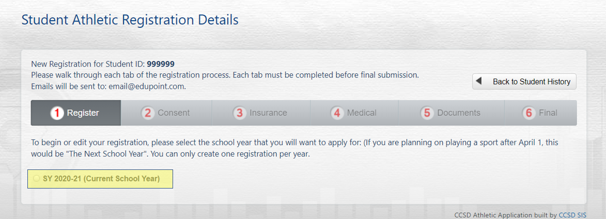

After selecting the year, an icon and name for each high school will display. Select the school that you wish to apply the registration by clicking the radial button next to the school name and icon. Only one school can be selected. Next select all the sports that you child wishes to participate in. Click the Save Selection button after making the selections.

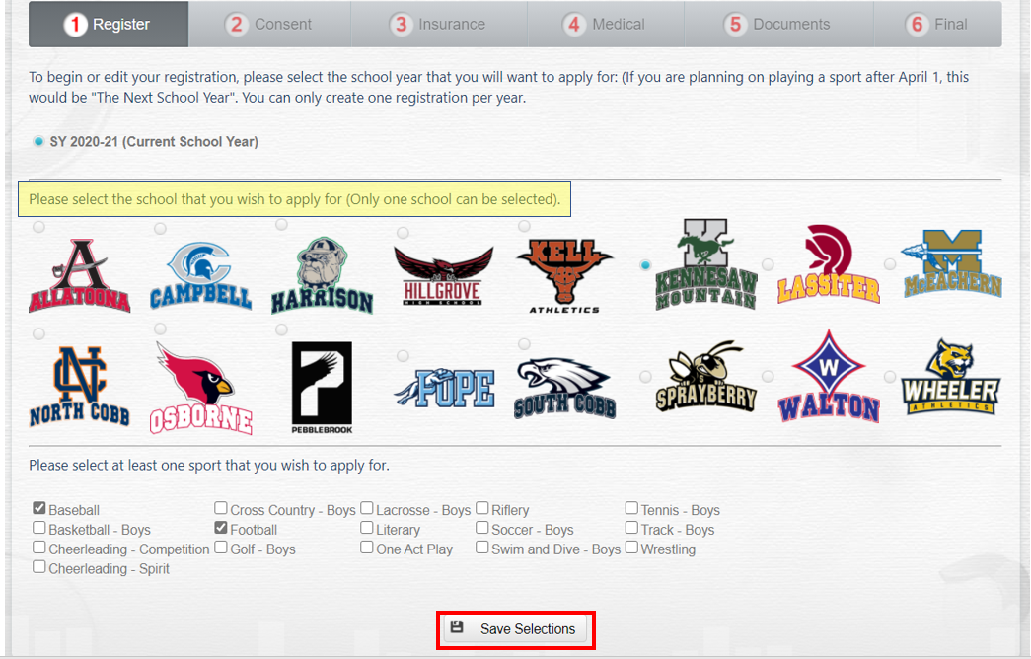

A successful message will display and step 1 will turn green, indicating the Register tab is complete.

## Saving a Registration before Completion

After completing the Register tab, if you need to leave the Athletic Registration prior to the completion, click the Back to Student History button.

The system will save the completed steps and you can continue where you left off when you return to the application later. To continue an Athletic Registration already in progress, follow the steps above to open the Athletic Registration Application. Then, click the edit pencil for the registration that is In Progress.

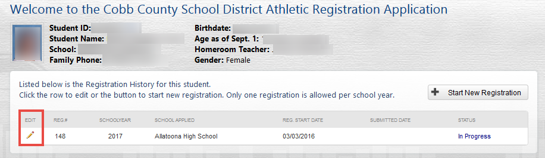

## Consent Tab

The Consent tab consists of seven areas that the parent/guardian is required to read and agree to, individually for each area. Click the Read button to open the details for a consent area.

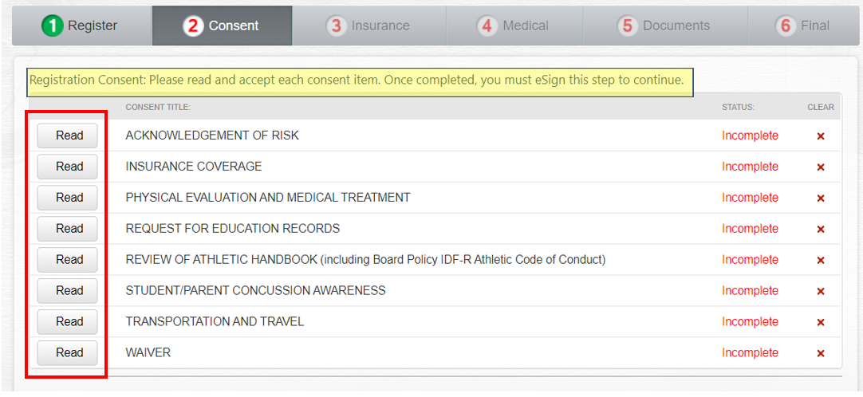

Read the details that display for the consent area. Then, click the box to agree.

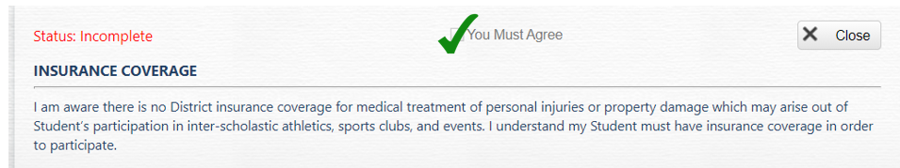

The details window will automatically close when the agreement box is checked, and the Accepted status will display on the screen for that consent area.



Continue through the list of consent areas. Read and accept each area individually.

When all consent areas are in the accepted status, the electronic signature area will display on the screen.

Click the box to add a check mark indicating you are the legal guardian and you accept and agree to the terms listed. Then, type your **ParentVUE login** in the field provided.

Click the e-Sign button, which only becomes available after entering the ParentVUE login.

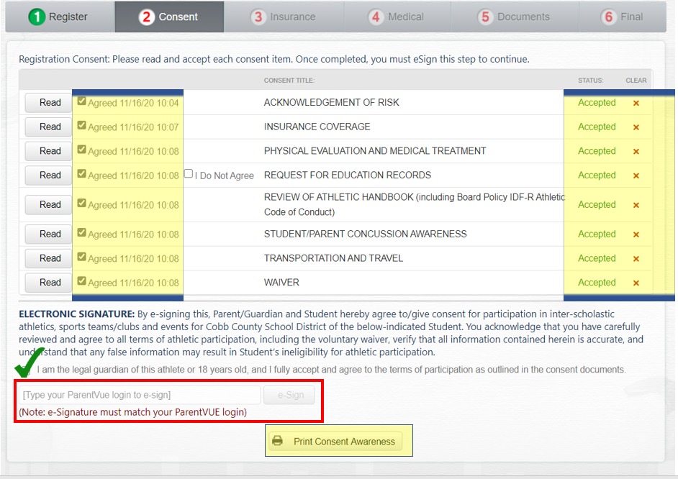

A successful message will display and step 2 will turn green indicating the Consent tab is complete.

***Be sure to click the button to Print Consent Awareness and keep a copy for your records.***

*Note: Upon completion of the registration, you will have the opportunity to print the entire Athletic Registration from the Final tab.*

## Insurance Tab

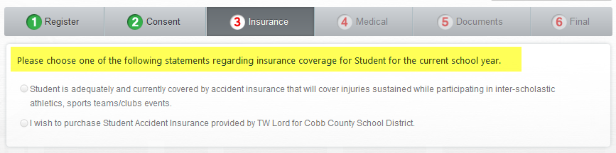On the Insurance tab, the parent/guardian should choose the appropriate radial button to indicate if the student currently has adequate accident insurance or wishes to purchase accident insurance from the vendor provided through the Cobb County School District.

If the student currently has insurance, complete all the required fields, providing information about the student’s policy. Then, click the Save Insurance Policy button.

If the parent/guardian selects the option to purchase insurance from the vendor provided by CCSD, the contact information for the insurance company will display.



After completing the required fields for the student’s insurance policy, or if the option to purchase a policy is selected, step 3 will turn green indicating that the Insurance tab is complete.

## Medical Tab

There are three forms on the Medical tab, a History Form and a Supplemental History Form and a presentation on Sudden Cardiac Arrest Awareness. The parent/guardian should click the View buttons to complete each form separately.

***Note: A blank physical form, required for the student’s medical exam, will be available to print after completing the History and Supplemental History Forms and after e-signing the Medical Tab.***

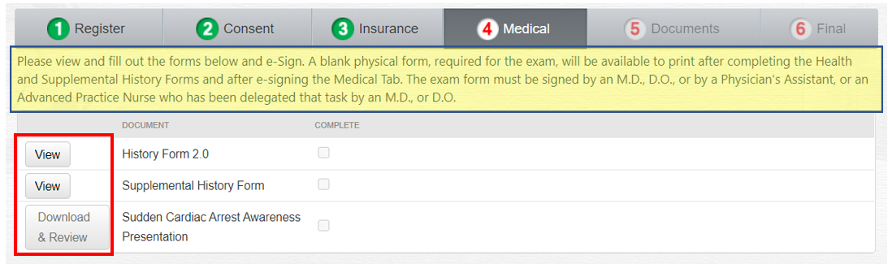

While completing either form, if you need to save and return later, scroll to the bottom of the screen. Click the Save and Continue button.

Follow the steps, listed earlier in this document, to open an Athletic Registration that is In Progress.

Upon returning to the form, all questions left unanswered will display in red font.

After both forms are complete and the presentation has been downloaded and viewed, the parent/guardian will see the electronic signature option on the screen.

Click the box to add a check mark acknowledging the information is correct. Then, type your **ParentVUE login** in the field provided.

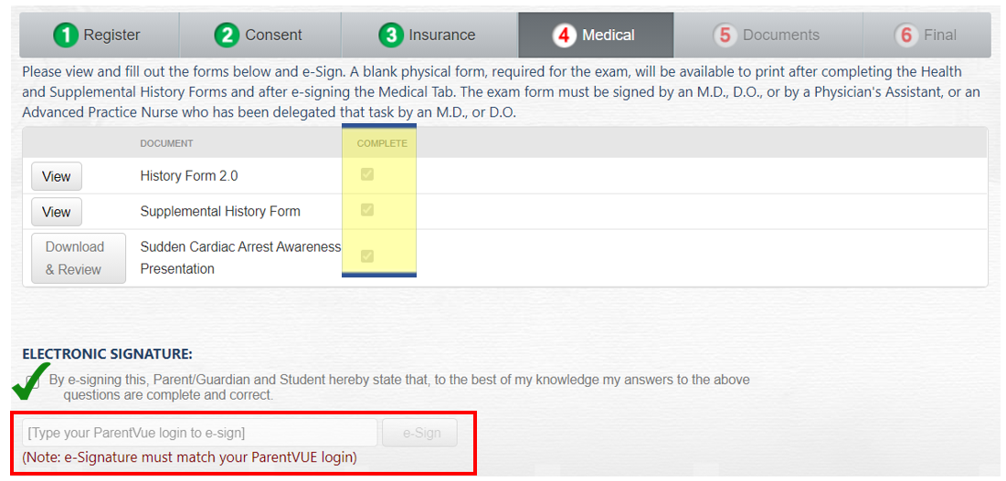Click the e-Sign button, which only becomes available after entering the ParentVUE login.

After e-signing, a successful message will display and step 4 will turn green indicating that the Medical tab is complete.

*IMPORTANT: Please print all forms, including the blank Physical Form that will be available after e-signing the Medical tab.* ***Take the blank Physical Form to the student’s physical exam.*** *It must be signed by an M.D., D.O., or by a Physician's Assistant, or an Advanced Practice Nurse who has been delegated that task by an M.D., or D.O.*

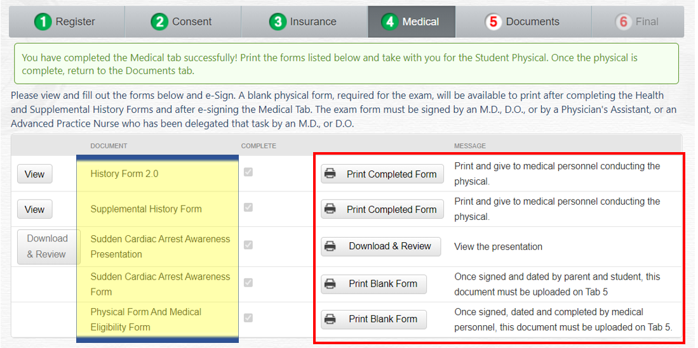

## Documents Tab

Please click the Upload A Document button to add the completed and signed Physician’s Physical Examination, Medical Eligibility, and Sudden Cardiac Arrest Awareness Forms to the Athletic Registration separately and designate each form appropriately.

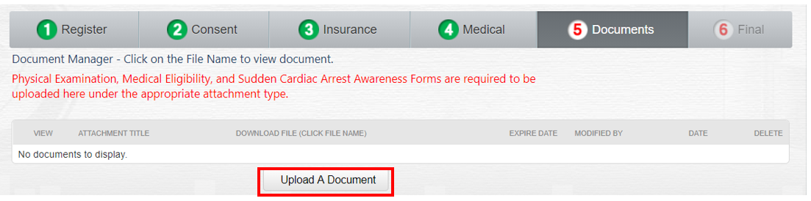

When the Document Manager Window displays, click the drop down menu to select the file you are uploading and then click the Select Your File button to navigate to your file’s location.  
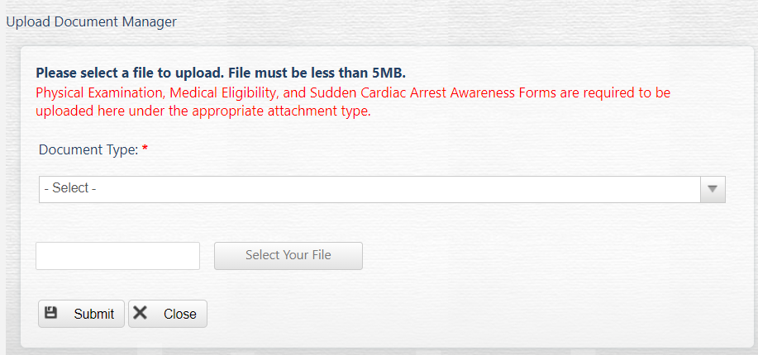

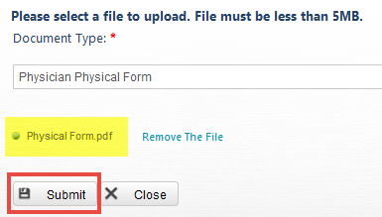

After uploading the physical form, click the Submit button.

*Note: If the Close button is clicked before the Submit button, the Document Manager Window will close without uploading the file.*

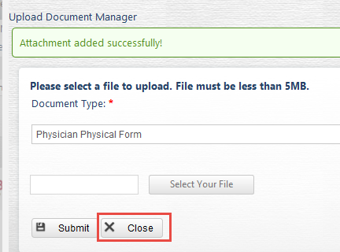When the Submit button is clicked, a successful message will display. Click the Close button to return to the Documents tab.

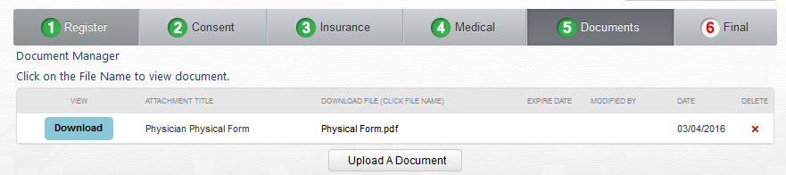Step 5 will turn green indicating that the Documents tab is complete.

## Final Tab

On the Final tab, the parent/guardian can print the entire, complete application.

Click the Submit My Application when all requirements are complete. Once you click the Submit My Application button, you will NOT be able to modify your application.

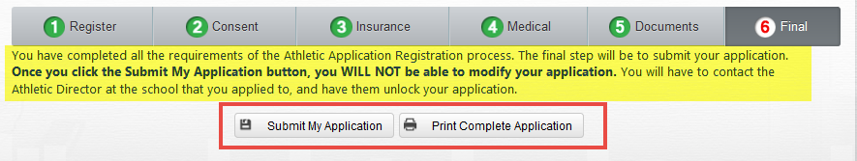You will be able to print the complete application at any time, even after the application is submitted and awaiting approval or after approval.

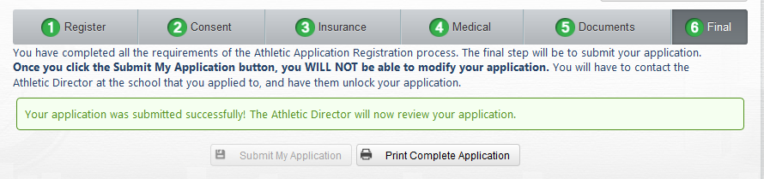After submitting the application, a successful message will display and step 6 will turn green indicating that the Final tab is complete. The Athletic Director, at the local school, will review the application.

## After Application is Submitted

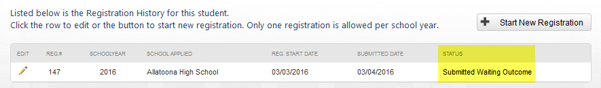After submitting the Athletic Registration Application, if you return to the system, the status displays as Submitted Waiting Outcome.

If the Athletic Director returns the application to the parent/guardian for more information, the status displays as Needs More Information.

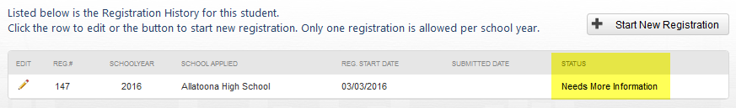Click the Edit pencil to open the registration and look for a message from the Athletic Director.

A message from the Athletic Director will display on the main screen.

When the Athletic Director approves and clears the application, the status displays as cleared.

